



E-PROJECT

**instructor name: Sir Hassan naeem**

Group Member

* Mustafa (1347574)

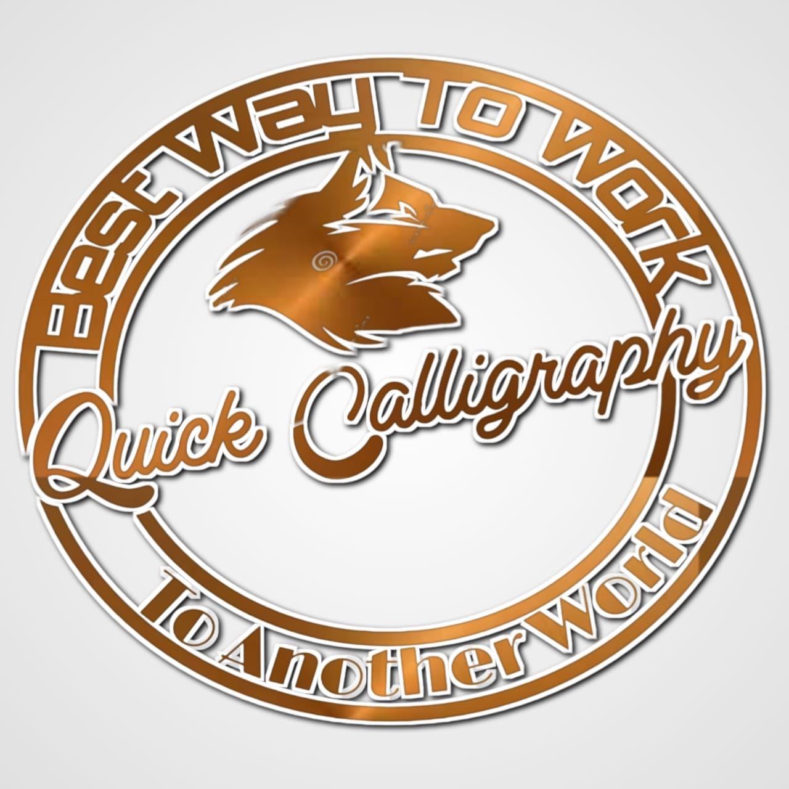

**Problem Statement**

Calligraphy is the art of forming beautiful symbols by hand and arranging them well. It's a set of skills and techniques for positioning and inscribing words so they show integrity, harmony, some sort of ancestry, rhythm and creative fire.

Calligraphy can be taken to expert heights. Calligraphy skills are used in many areas of art and graphics, from greetings card design to tattoo artistry. But you don't have to be a pro to express your creative self and have a pleasant effect on the viewer or recipient of your efforts.

Essentially, there are three main types of calligraphy: Western, Arabic, and Oriental. Within each style, there may be several lettering sub-styles or hands. Seeing examples of these styles can help you perfect your art and get inspired to create something amazing.

Here we are aiming to design a website “QuickCalligraphy” which will provide an easy way to learn calligraphy and provide the basic other details about the art.

* **Requirement**

The Web site is to be created based on the following requirements.

1. The home page must describe the keywords or highlight the calligraphy designs with all navigation links defined.
2. The site should provide the brief information about calligraphy as from where it originated etc.
3. There should be a well-designed menu with necessary sub menu options.
4. There should be various categories (forms and styles) like easy for kids, complex for elders and so on
5. There should also be categories of designs as Arabic, Indic, Greek etc. (more categories can be added)
6. Proper description of the letters and fonts must be added in the website.
7. Contact us page: contact us details with location should be displayed using Geolocation API (e.g. Google Maps).
8. About Us
9. Feedback form
10. Gallery section should be added.
11. Color combination must be uniform throughout the project.
12. Navigation must be smooth.



Screenshots: Home Page

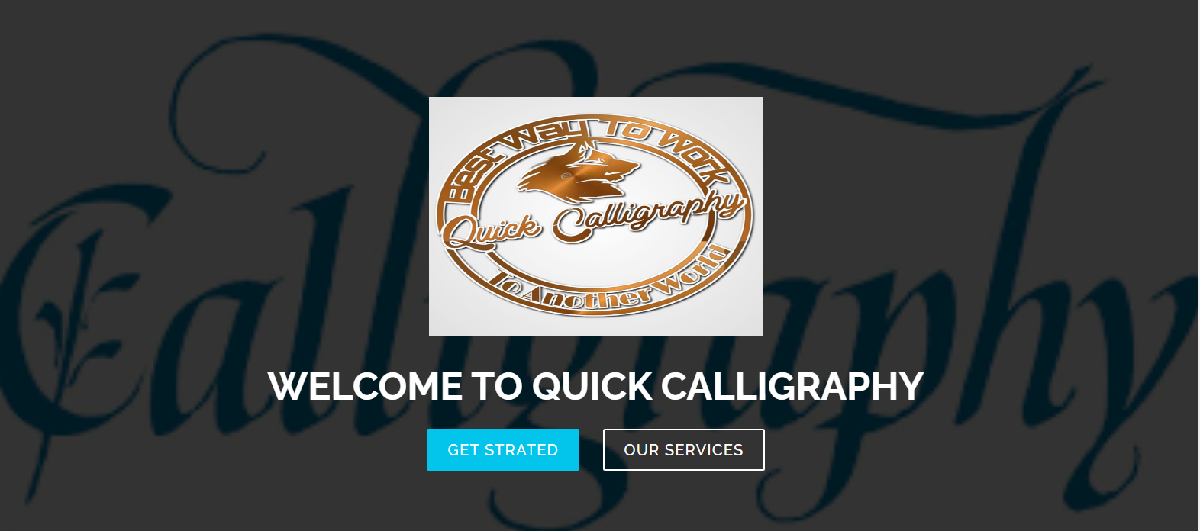



Plain Your Visit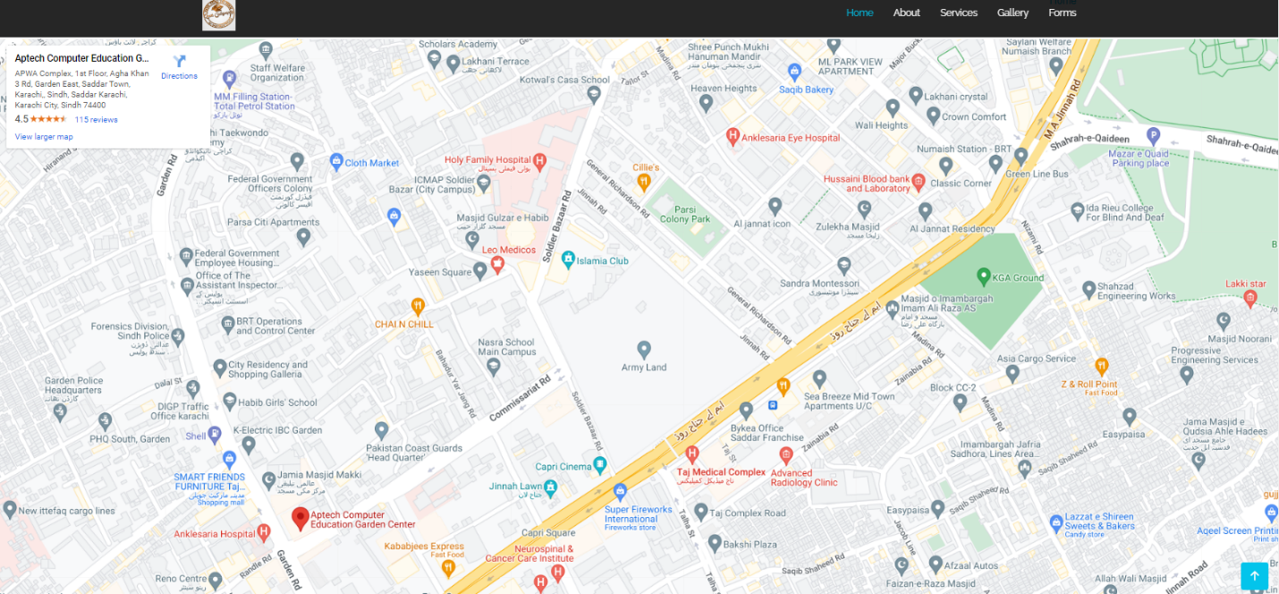



About Us

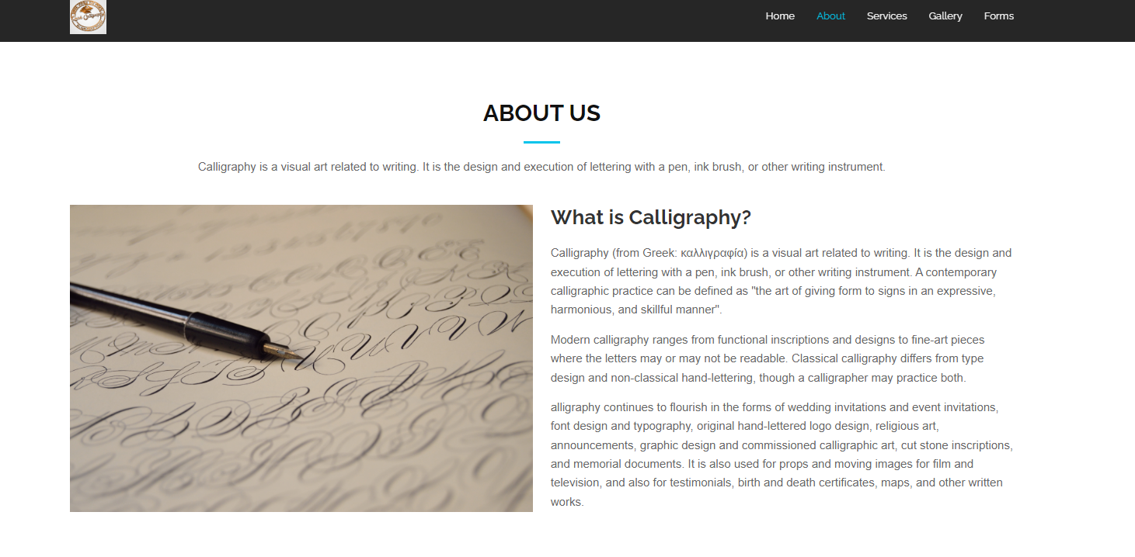



Contact Us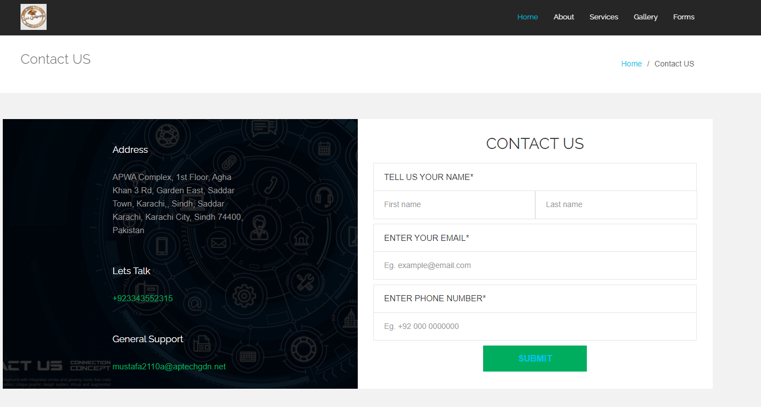



Feedback Form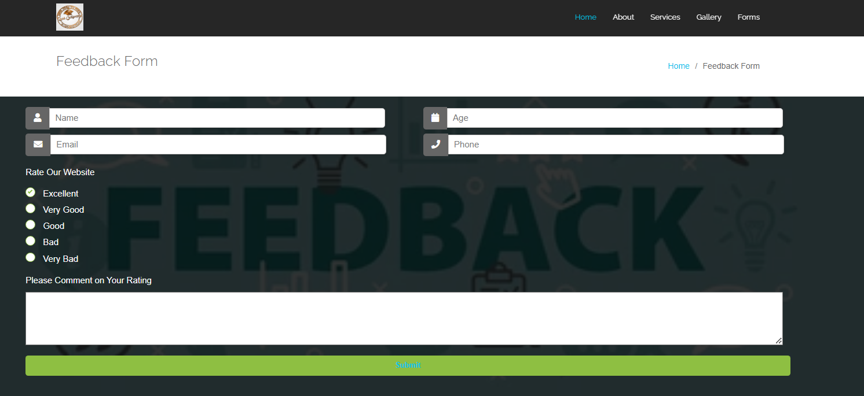



Services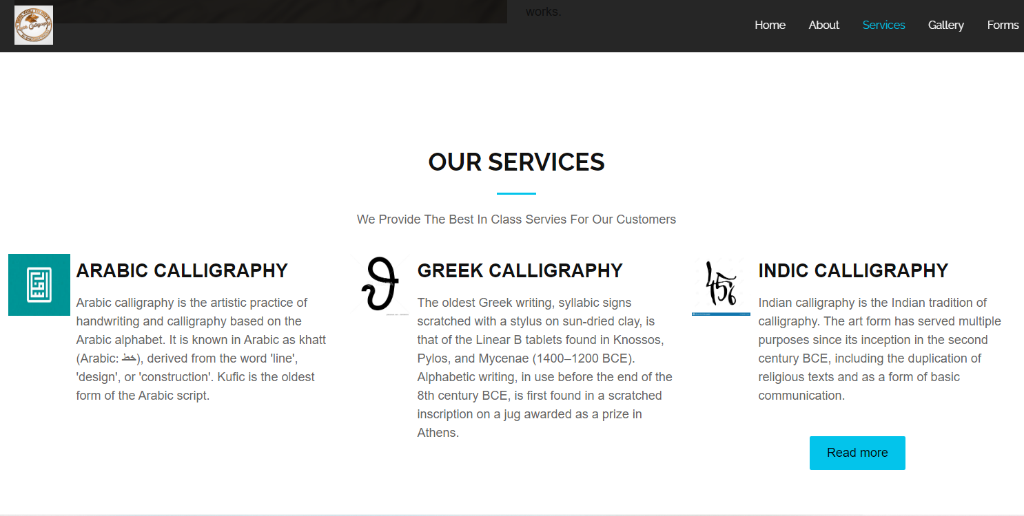



Detail Services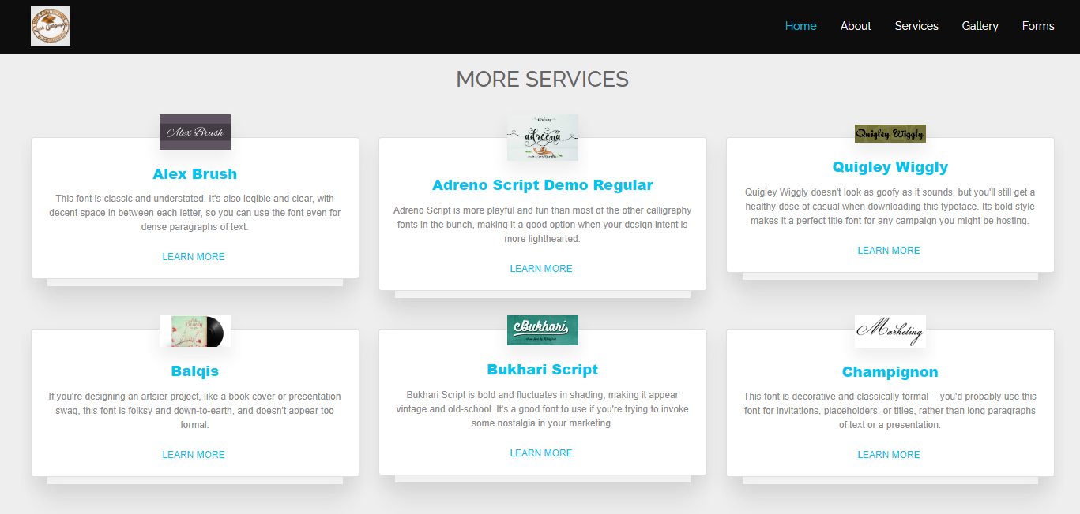



Gallery

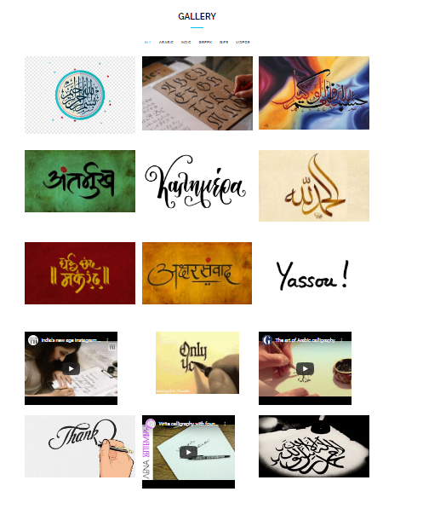



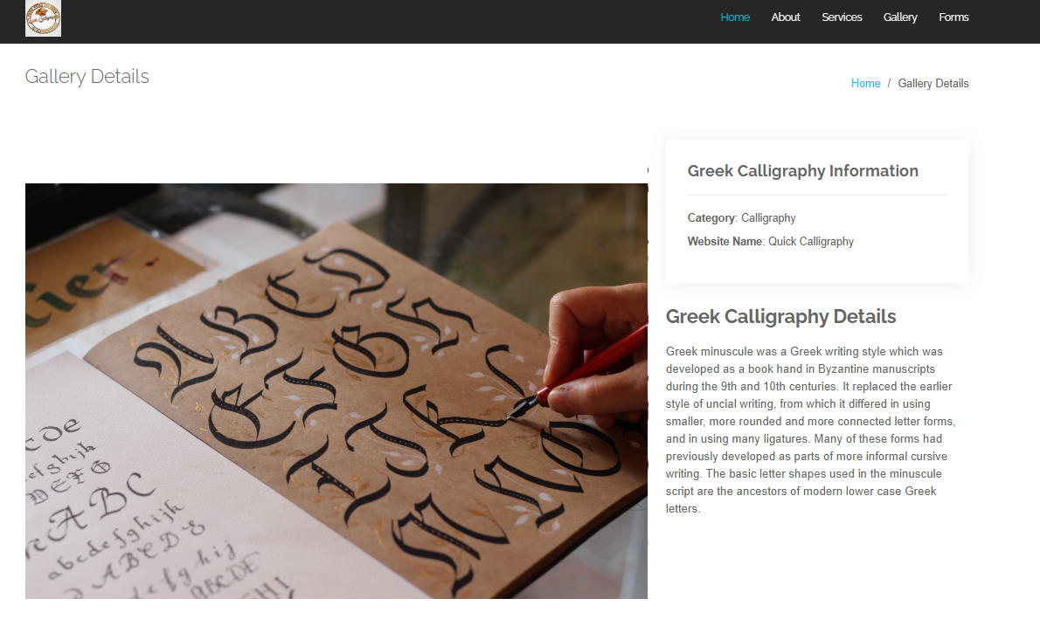Detail Gallery Pages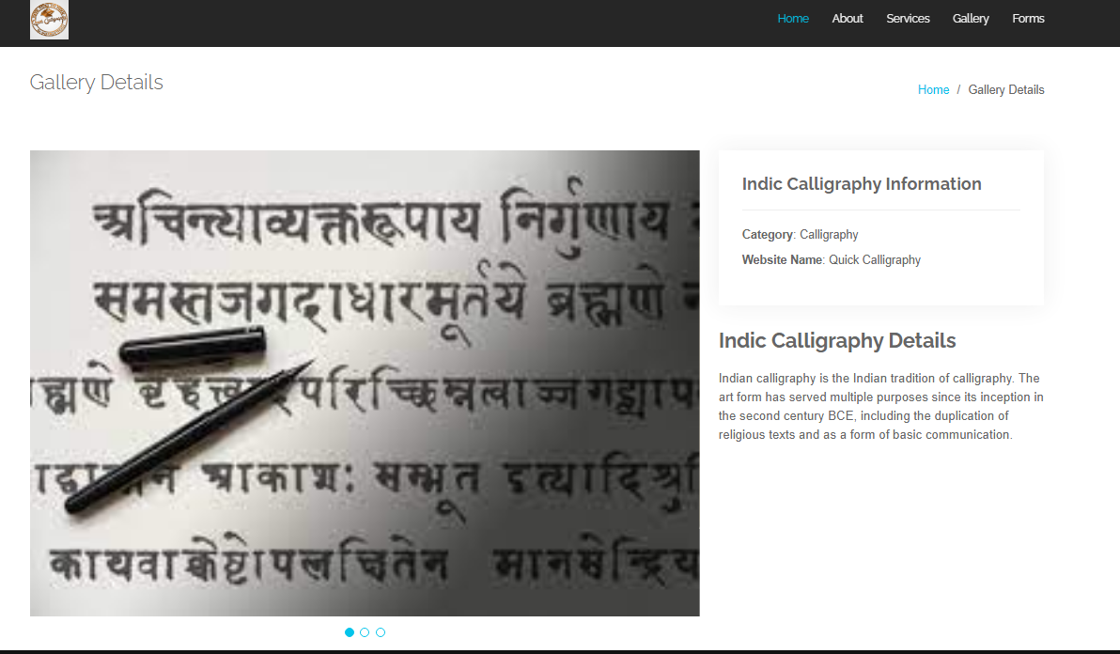



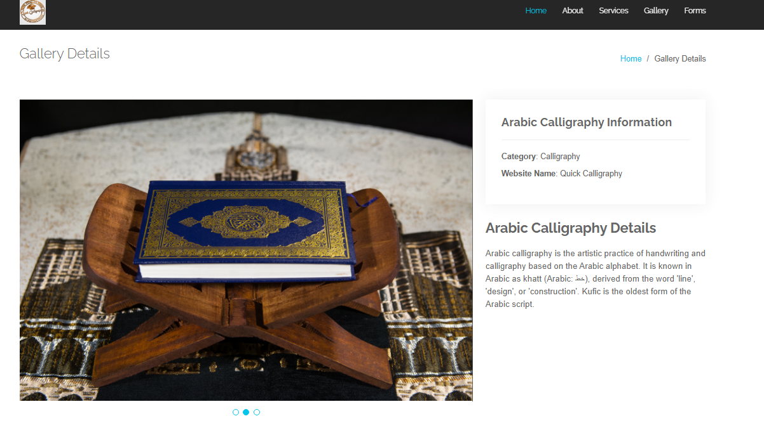



Mustafa

Special Thanks For Faculty

Sir: Hassan Naeem